Copyright for test papers and marking guides remains with West Australian Test Papers.
Test papers may only be reproduced within the purchasing school according to the advertised Conditions of Sale.
Test papers should be withdrawn after use and stored securely in the school until Friday 30th November 2018.



SEMESTER TWO

MATHEMATICS
SPECIALIST
UNITS 1 & 2

2018

SOLUTIONS

Calculator−free Solutions

1. (a) (i) ${}_{ }^{8}{P_{5}}$ or ${}_{ }^{8}{C_{5}}×5!$
(ii) ${}_{ }^{4}{C_{3}}×{}_{ }^{4}{C_{2}}×5!$

(b) (i) $6^{4}×5^{2}×6!$
(ii) ‘9’ from first set only: ${}_{ }^{5}{C_{3}}×{}_{ }^{4}{C_{2}}×6!$
‘9’ from second set only: ${}_{ }^{5}{C_{4}}×{}_{ }^{4}{C_{1}}×6!$
no ‘9’ chosen: ${}_{ }^{5}{C_{4}}×{}_{ }^{4}{C_{2}}×6!$
total $=\left({}_{ }^{5}{C_{3}}×{}_{ }^{4}{C_{2}}+{}_{ }^{5}{C_{4}}×{}_{ }^{4}{C_{1}}+{}_{ }^{5}{C_{4}}×{}_{ }^{4}{C_{2}}\right)×6!$ [8]

2. (a) (i) $i^{n+2}=i^{n}×i^{2}=-i×-1=i$
(ii) $i^{2n+1}={\left(i^{n}\right)}^{2}×i={\left(-i\right)}^{2}×i=-i$
(b) $\frac{1-i}{i+\frac{2}{i}}×\frac{i}{i}=\frac{i-i^{2}}{i^{2}+2}=\frac{1+i}{-1+2}=1+i$
(c) ${\left(1+i\right)}^{4}-{\left(1-i\right)}^{4}$
$=\left[{\left(1+i\right)}^{2}+{\left(1-i\right)}^{2}\right]×\left[{\left(1+i\right)}^{2}-{\left(1-i\right)}^{2}\right]$
$=\left[1+2i-1+1-2i-1\right]×\left[1+2i-1-1+2i+1\right]$
$=0×4i=0$ [7]

3. (a) $5^{3}=5+1×10×6+1×4×15=5+60+60=125$
(b) ${}_{ }^{5}{C_{2}} , {}_{ }^{4}{C_{1}}$
(c) $n^{3}=n+{}_{ }^{n-1}{C_{0}}×{}_{ }^{n+1}{C_{1}}×{}_{ }^{n}{C_{2}}+{}_{ }^{n}{C_{0}}×{}_{ }^{n-1}{C_{1}}×{}_{ }^{n+1}{C_{2}}$ [5]

4. (a) (i) $\left[\begin{matrix}0 & -1 & 1 \\ 1 & 1 & -1 \\ 1 & 1 & 0\end{matrix}\right]×\left[\begin{matrix}1 & 1 & 0 \\ -1 & -1 & 1 \\ 0 & -1 & 1\end{matrix}\right]=\left[\begin{matrix}1 & 0 & 0 \\ 0 & 1 & 0 \\ 0 & 0 & 1\end{matrix}\right]$

A and B are inverses of each other.

(ii) $\left[\begin{matrix}0 & -1 & 1 \\ 1 & 1 & -1 \\ 1 & 1 & 0\end{matrix}\right]×\left[\begin{matrix}x \\ y \\ z\end{matrix}\right]=\left[\begin{matrix}-6 \\ 8 \\ 3\end{matrix}\right]$
$\left[\begin{matrix}x \\ y \\ z\end{matrix}\right]={\left[\begin{matrix}0 & -1 & 1 \\ 1 & 1 & -1 \\ 1 & 1 & 0\end{matrix}\right]}^{-1}×\left[\begin{matrix}-6 \\ 8 \\ 3\end{matrix}\right]=\left[\begin{matrix}1 & 1 & 0 \\ -1 & -1 & 1 \\ 0 & -1 & 1\end{matrix}\right]×\left[\begin{matrix}-6 \\ 8 \\ 3\end{matrix}\right]=\left[\begin{matrix}2 \\ 1 \\ -5\end{matrix}\right]$
$∴x=2, y=1, z=-5$

4. (b) (i) T₁ performs a rotation of 180°
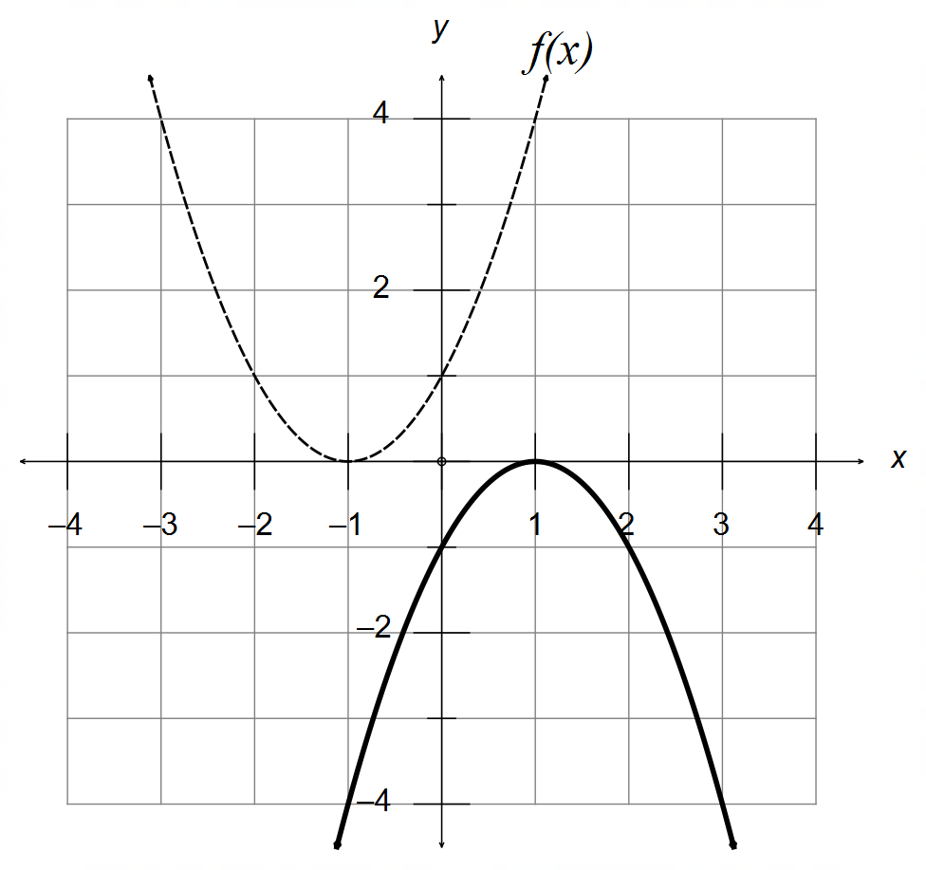

$∴y=-{\left(x-1\right)}^{2}$

(ii) Reflection of the line $y=x$
T₂$=\left[\begin{matrix}0 & 1 \\ 1 & 0\end{matrix}\right]$

(iii) New Area $=\left|T_{3}\right|×10\frac{2}{3}=6×\frac{32}{3}=64 units^{2}$ [12]

5. (a) (i) $y=-3\cos\left[4\left(x-\frac{π}{12}\right)\right]=-3\cos\left[4x-\frac{π}{3}\right]$
$∴ A=-3 ω=4 θ=-\frac{π}{3}$

(ii) $y=-3\sin\left(4x+\frac{π}{6}\right)$
(b)
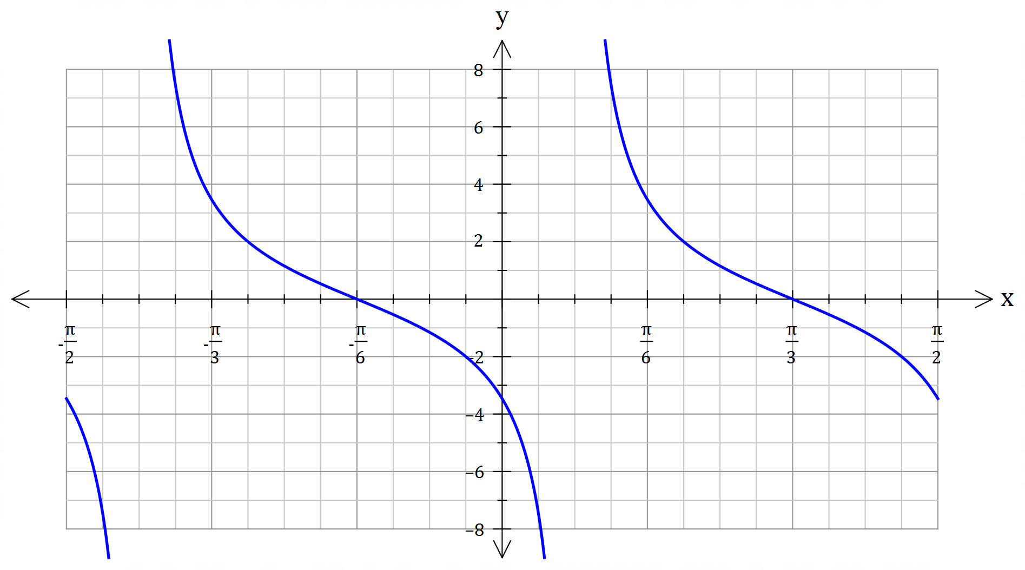
Scale factor
($y=2$ at $x=\frac{5π}{24}$)

Period of $\frac{π}{2}$

Vertical Asymptote
at $x=\frac{π}{12}$

[8]

6. (a) (i) $\sqrt{2}×\sqrt{8}=\sqrt{16}=4$
(ii) “If $ab$ is irrational, then both $a$ and $b$ must be irrational”

(b) A ⇒ B: If the triangle has two equal sides, then it is isosceles,
and therefore it has two congruent sides.
$∴$ A ⇒ B is valid and True.

B ⇒ A: If the triangle has two congruent sides, then it is isosceles,
and therefore it has two equal sides.
$∴$ B ⇒ A is valid and True.

$∴$ A ⇔ B

(c) $∀x∈P, ∃ y∈ P :xy∈Q$ [6]

7. Assume $n$ is even and that $n^{3}$ is odd.
Let $m∈N:n=2m$ is even.
$n^{3}={\left(2m\right)}^{3}=8m^{3}=2\left(4m^{3}\right)$
Since $n^{3}$ cannot be both even and odd simultaneously, then this
is a contradiction. And therefore $n$ must be odd. [4]
Calculator−assumed Solutions

8. (a) $z=\frac{4±\sqrt{16-24}}{4}=1±\frac{\sqrt{2}}{2}i$
$P\left(z\right)=\left(z-1-\frac{\sqrt{2}}{2}i\right)\left(z-1+\frac{\sqrt{2}}{2}i\right)$

(b) Since $a,b,c∈R$ then $\overline{z}=2-i$ is also a solution
$∴R\left(z\right)=\left(z+1\right)\left(z-2-i\right)\left(z-2+i\right)$
$=z^{3}-3z^{2}+z+5$
$∴a=-3 b=1 c=5$ [5]

9. LHS $=\frac{\tan{θ}+\tan{\frac{π}{4}}}{1-\tan{θ}×\tan{\frac{π}{4}}}$
$=\frac{\tan{θ}+1}{1-\tan{θ}}$
$=\frac{\frac{\sin{θ}}{\cos{θ}}+1}{1-\frac{\sin{θ}}{\cos{θ}}}$
$=\frac{\frac{\sin{θ}}{\cos{θ}}+1}{1-\frac{\sin{θ}}{\cos{θ}}}×\frac{\cos{θ}}{\cos{θ}}$
$=\frac{\sin{θ}+\cos{θ}}{\cos{θ}-\sin{θ}}$
$=\frac{\sin{θ}+\cos{θ}}{\cos{θ}-\sin{θ}}×\frac{\cos{θ}+\sin{θ}}{\cos{θ}+\sin{θ}}$
$=\frac{\sin^{2}{θ}+\cos^{2}{θ}+2\sin{θ}\cos{θ}}{\cos^{2}{θ}-\sin^{2}{θ}}$
$=\frac{1+\sin{2θ}}{\cos{2θ}}=$RHS [8]

10. (a) (i) $\left(\begin{matrix}3 \\ 1\end{matrix}\right)=k\left(\begin{matrix}α \\ -2\end{matrix}\right) → k=-\frac{1}{2} → α=-6$
(ii) $a+c=\left(\begin{matrix}3+α \\ -1\end{matrix}\right) → \left(\begin{matrix}3+α \\ -1\end{matrix}\right)∙\left(\begin{matrix}1 \\ -3\end{matrix}\right)=0 →α=-6$

(b) $\left(\begin{matrix}1 \\ 5\end{matrix}\right)∙\left(\begin{matrix}6 \\ 4\end{matrix}\right)=\left|\begin{matrix}1 \\ 5\end{matrix}\right|×\left|\begin{matrix}6 \\ 4\end{matrix}\right|×\cos{θ} → \cos{θ}=\frac{1}{\sqrt{2}}$
$\left|m\right|=\left|\begin{matrix}1 \\ 5\end{matrix}\right|=\sqrt{26}$
$\hat{n}=\frac{1}{2\sqrt{13}}\left(\begin{matrix}6 \\ 4\end{matrix}\right)$
${}_{m}^{ }{proj_{n}}=\left|m\right|\cos{θ}\hat{n}=\sqrt{26}×\frac{1}{\sqrt{2}}×\frac{1}{2\sqrt{13}}\left(\begin{matrix}6 \\ 4\end{matrix}\right)=\left(\begin{matrix}3 \\ 2\end{matrix}\right)=3i+2j$ [8]

11. (a) $S_{3}=\frac{1}{2!}+\frac{2}{3!}=\frac{1}{2}+\frac{2}{6}=\frac{5}{6}$
$S_{4}=\frac{1}{2!}+\frac{2}{3!}+\frac{3}{4!}=\frac{1}{2}+\frac{2}{6}+\frac{3}{24}=\frac{23}{24}$

(b) $\frac{3!-1}{3!}=\frac{6-1}{6}=\frac{5}{6}$
$\frac{4!-1}{4!}=\frac{24-1}{24}=\frac{23}{24}$

(c) $S_{n}=\frac{1}{2!}+\frac{2}{3!}+\frac{3}{4!}+…+\frac{n-1}{n!}=\frac{n!-1}{n!}$

(d) For $n=2$: $S_{2}=\frac{1}{2}$ and $\frac{2!-1}{2!}=\frac{1}{2} ∴$ True for $n=2$

Assume true for $n=k$:
$S_{k}=\frac{1}{2!}+\frac{2}{3!}+\frac{3}{4!}+…+\frac{k-1}{k!}=\frac{k!-1}{k!}$

For $n=k+1$:
$S_{k+1}=\frac{1}{2!}+\frac{2}{3!}+\frac{3}{4!}+…+\frac{k-1}{k!}+\frac{\left(k+1\right)-1}{\left(k+1\right)!}$
$=S_{k}+\frac{k}{\left(k+1\right)!}=\frac{k!-1}{k!}+\frac{k}{\left(k+1\right)!}$
$=\frac{k!-1}{k!}×\frac{k+1}{k+1}+\frac{k}{\left(k+1\right)!}$
$=\frac{k!\left(k+1\right)-\left(k+1\right)}{\left(k+1\right)!}+\frac{k}{\left(k+1\right)!}$
$=\frac{\left(k+1\right)!-1}{\left(k+1\right)!}$ as required

Therefore, True for n = k + 1, and since true for n =2,
by induction the conjecture is true for all whole numbers. [10]

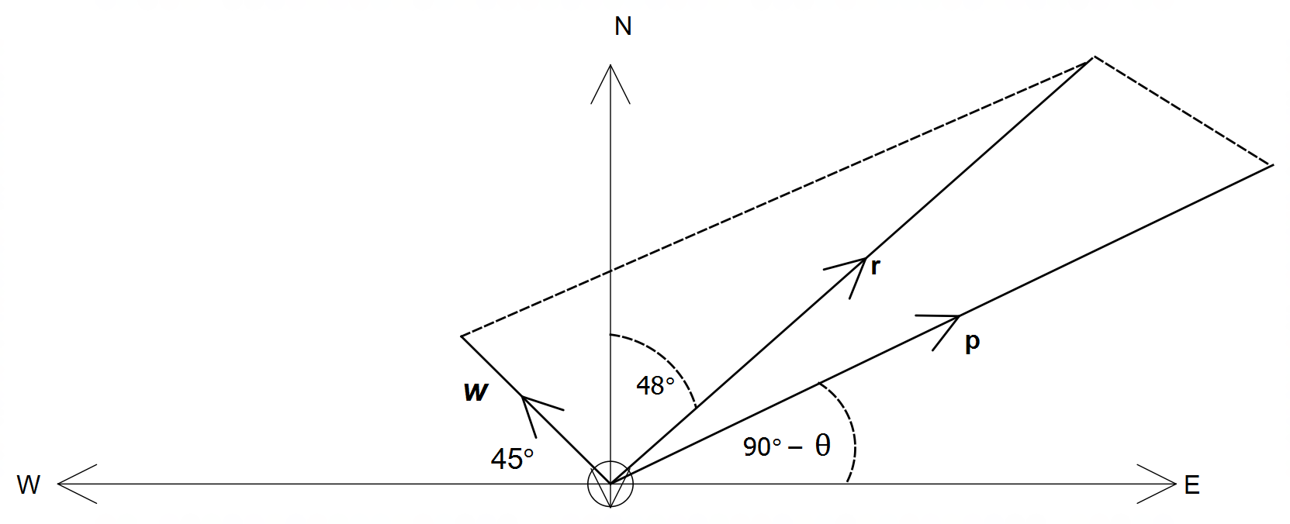12. (a)
resultant

wind
plane

(b) $w=\left(\begin{matrix}-80\cos{45°} \\ 80\sin{45°}\end{matrix}\right)=\left(\begin{matrix}-40\sqrt{2} \\ 40\sqrt{2}\end{matrix}\right)$
$r=\left(\begin{matrix}r\cos{42°} \\ r\sin{42°}\end{matrix}\right)$
$p=\left(\begin{matrix}870\cos\left(90°-θ\right) \\ 870\sin\left(90°-θ\right)\end{matrix}\right)=\left(\begin{matrix}870\sin{θ} \\ 870\cos{θ}\end{matrix}\right)$

(c) $p+\left(\begin{matrix}-40\sqrt{2} \\ 40\sqrt{2}\end{matrix}\right)=\left(\begin{matrix}r\cos{42°} \\ r\sin{42°}\end{matrix}\right)$
$∴\left|p\right|=\left|\begin{matrix}40\sqrt{2}+r\cos{42°} \\ -40\sqrt{2}+r\sin{42°}\end{matrix}\right|=870$
CAS: $r=862.14$kmh⁻¹
$θ=53.27°$

(d) $t=\frac{d}{v}=\frac{878}{862.14}=1.018hrs=1 hour and 1 minute$ [11]

13. (a) $P\left(Q-I\right)=Q+I$
$∴P=\left(Q+I\right){\left(Q-I\right)}^{-1}$
$=\left[\begin{matrix}2 & 3 \\ -2 & 2\end{matrix}\right]×{\left[\begin{matrix}0 & 3 \\ -2 & 0\end{matrix}\right]}^{-1}=\left[\begin{matrix}2 & 3 \\ -2 & 2\end{matrix}\right]×\frac{1}{6}\left[\begin{matrix}0 & -3 \\ 2 & 0\end{matrix}\right]$
$∴P=\left[\begin{matrix}1 & -1 \\ \frac{2}{3} & 1\end{matrix}\right]$

(b) $A^{4}=A^{2}×A^{2}=\left(3A-2I\right)×\left(3A-2I\right)$
$=9A^{2}-12A+4I$
$=9\left(3A-2I\right)-12A+4I$
$=27A-18I-12A+4I$
$∴A^{4}=15A-14I$ [6]
14. (a) $f\left(x\right)=R\cos\left(2x+θ\right)$
$=R\cos{2x}\cos{θ}-R\sin{2x}\sin{θ}=\cos{2x}-\sqrt{3}\sin{2x}$
$∴R\sin{θ}=\sqrt{3} R\cos{θ}=1$
$⇒R=2 θ=60°$
$f\left(x\right)=2\cos\left(2x+60°\right)$

(b) $f\left(x\right)=2\cos\left(2x+60°\right)=-1$
$\cos\left(2x+60°\right)=-\frac{1}{2}$
$∴2x+60°=120°, 240°, 480°, 600°$
$x=30°, 90°, 210°, 270°$ [6]

15. (a) (i) $P=\left[\begin{matrix}-2 & 3 \\ 2 & -3\end{matrix}\right]×{\left[\begin{matrix}2 & 1 \\ 0 & 2\end{matrix}\right]}^{-1}=\left[\begin{matrix}-1 & 2 \\ 1 & -2\end{matrix}\right]$
$∴k=-2$

(ii) $\left|P\right|=k\left(k+1\right)-2=k^{2}+k-2≠0$
$∴k≠-2, 1$

(b) (i) $M^{2n+1}={\left(M^{2}\right)}^{n}×M=I^{n}×M=M$
(ii) $M^{-2n}={\left(M^{2}\right)}^{-n}=I^{-n}=I$

(c) $A^{n}=\left[\begin{matrix}1 & 0 \\ 2^{n}-1 & 2^{n}\end{matrix}\right]$ [8]

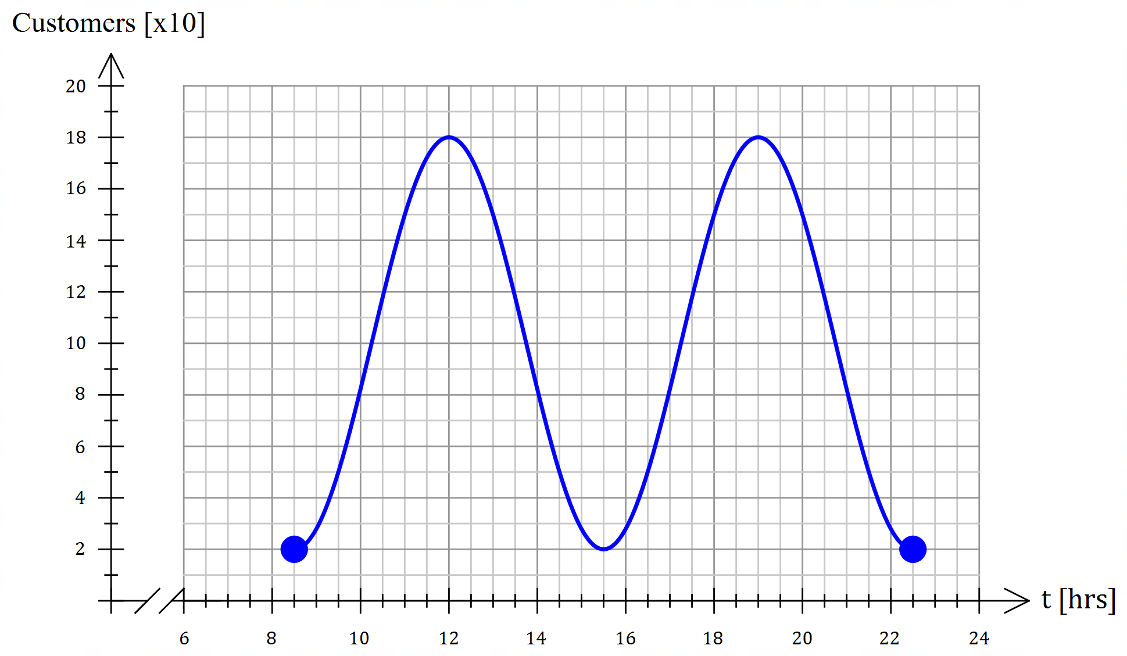16. (a)

Amplitude
Period = 7hrs
two full waves

16. (b) $C\left(t\right)=-80\cos\left[\frac{2π}{7}\left(t-8.5\right)\right]+100$
$A=-80, ω=\frac{2π}{7}, ϕ=\frac{17π}{7}, v=100$

OR $A=80, ω=\frac{2π}{7}, ϕ=\frac{24π}{7}, v=100$

(c) $-80\cos\left[\frac{2π}{7}t-\frac{17π}{7}\right]+100=140$
CAS: $t_{1}=10.83, t_{2}=13.17, { t}_{3}=17.83, { t}_{4}=20.18$
Between 10:50am and 1:11pm
and 5:50pm and 8:11pm [12]

17. (a) (i) $5-4i$
(ii) $6i$
(iii) $3+5i$
(iv) $3-5i$
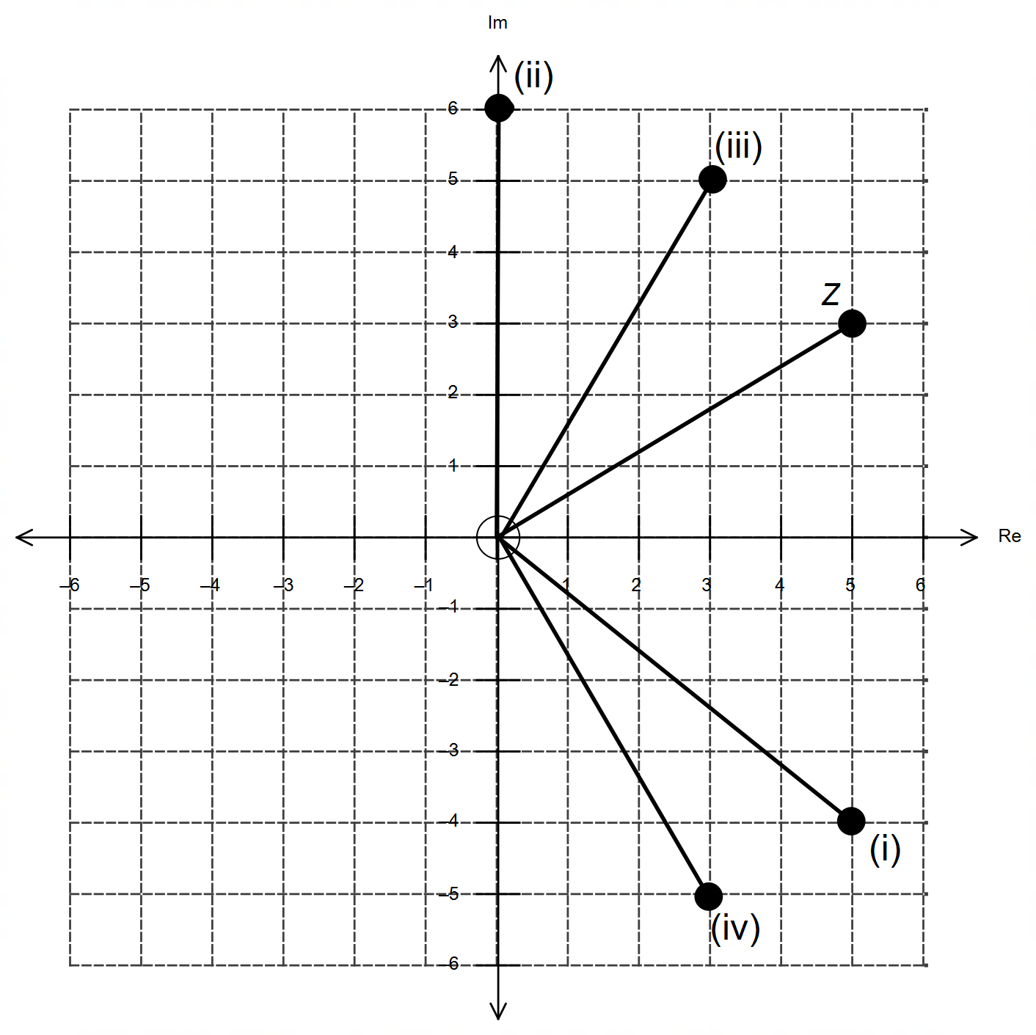

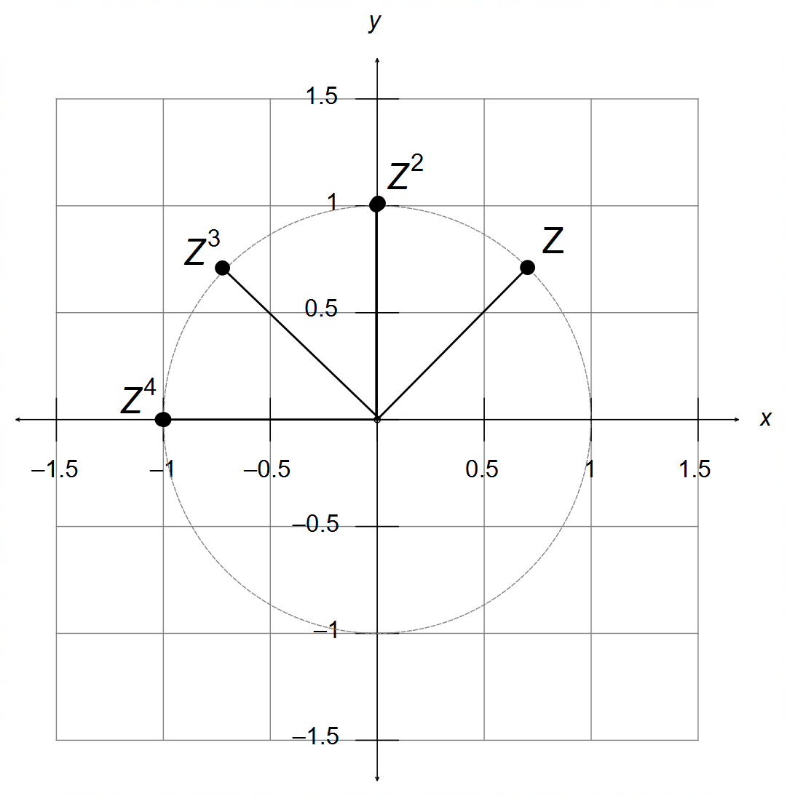17. (b) (i)

(ii) Rotation of 45° anticlockwise

(iii) Powers that are multiples of 8 give $z^{8n}=1$ [14]

18. (a) $\left|T\right|=\cos{θ}\cos{ϕ}+\sin{θ}\sin{ϕ}=0$
$∴\cos\left(θ-ϕ\right)=0$
$∴θ-ϕ=±90°$

(b) (i) $T=\left[\begin{matrix}0 & -1 \\ 1 & 0\end{matrix}\right]$
Rotation of 90° anti-clockwise

(ii) $T=\left[\begin{matrix}0 & -1 \\ -1 & 0\end{matrix}\right]$
Reflection over the line $y=-x$

(c) i.e. $T^{2}=I$
$\left[\begin{matrix}\cos{θ} & -\sin{ϕ} \\ \sin{θ} & \cos{ϕ}\end{matrix}\right]×\left[\begin{matrix}\cos{θ} & -\sin{ϕ} \\ \sin{θ} & \cos{ϕ}\end{matrix}\right]=\left[\begin{matrix}1 & 0 \\ 0 & 1\end{matrix}\right]$
$\left[\begin{matrix}\cos^{2}{θ}-\sin{θ}\sin{ϕ} & -\sin{ϕ}\left(\cos{θ}+\cos{ϕ}\right) \\ \sin{θ}\left(\cos{θ}+\cos{ϕ}\right) & \cos^{2}{ϕ}-\sin{θ}\sin{ϕ}\end{matrix}\right]=\left[\begin{matrix}1 & 0 \\ 0 & 1\end{matrix}\right]$
$\sin{θ}\left(\cos{θ}+\cos{ϕ}\right)=-\sin{ϕ}\left(\cos{θ}+\cos{ϕ}\right)=0$
$∴\sin{θ}=\sin{ϕ}=0$ and $\cos^{2}{θ}=\cos^{2}{ϕ}=1$

OR $\cos{θ}+\cos{ϕ}=0$ and $\sin{θ}=\sin{ϕ}$ [12]

